Walk Two Old Colliery Railways

Reasonable fitness for this walk folks! Go on Challenge Yourself
It is about 6 miles and involves quite a long climb.
Our volunteer Geoff carried out this walk during lockdown to contribute to the Tyne and Wear Heritage Forum ‘My Heritage Walks’ challenge- Why not give it a go yourself !

Background : For hundreds of years, coal has been mined in this area with much of the output going to the South by sea-going colliers. The problem for the mine owners was getting the coal from the pits to the staiths on a river where the coal could be loaded onto the ships.
The solution was originally wagonways. Horse-drawn carts on wooden rails but by the early 1800’s this was replaced by steam powered, metal rail systems. Locomotives replaced the horses on level terrain but steam powered winding engines moved wagons on steeper ground using long ropes. Occasionally gravity-incline planes used the weight of full wagons to pull empties back up a slope.
This walk traces two important railways in this area. The Pelaw Main Colliery Railway running from Ouston to Pelaw (Bill Quay staiths) with junctions to pits in the Team Valley and the Bowes Railway running from Dipton to Jarrow staiths.

Start : The carpark for the Angel of the North (only accessible on the northbound carriageway of the A167).
Cross the road at the traffic lights at the car park to be on the east side the A167 and turn left. On your right was the site of a colliery, known as Team Colliery (or Ravensworth Ann Pit). The pit baths were on the opposite side of the road where the Angel is now.
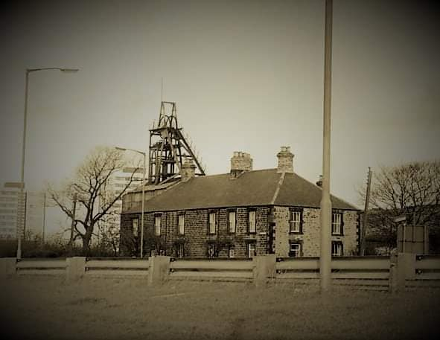
After 100m or so turn right through a gap and circle round to the left to go through a tunnel under the A167. You are now on the Pelaw Main Colliery railway (later absorbed into the Bowes Railway). Walk down the track until it meets Smithy Lane. You can see where the line ran across the road on its way to Allerdene Pit, but you turn left along the footpath where the Lane soon bridges the A1. Just before it crosses the bridge for the East Coast mainline, turn sharp left into Longacre Wood.

Keep to the major path through the wood, following the red “walking man” signs and following the direction of the main rail line. The path eventually exits at the south-west corner very close to the railway. Take the lane up to a gate and Long Acre Farm. Walk on the grass verge beside this busy road for a couple of hundred metres to cross a brick bridge. Turn left down steps on the far side of the bridge and turn right onto the track.

This is the Bowes Railway track coming from Dipton, Burnopfield, Byermoor, Marley Hill, Blackburn Fell and Kibblesworth Collieries to the west, en route to the staiths at Jarrow.

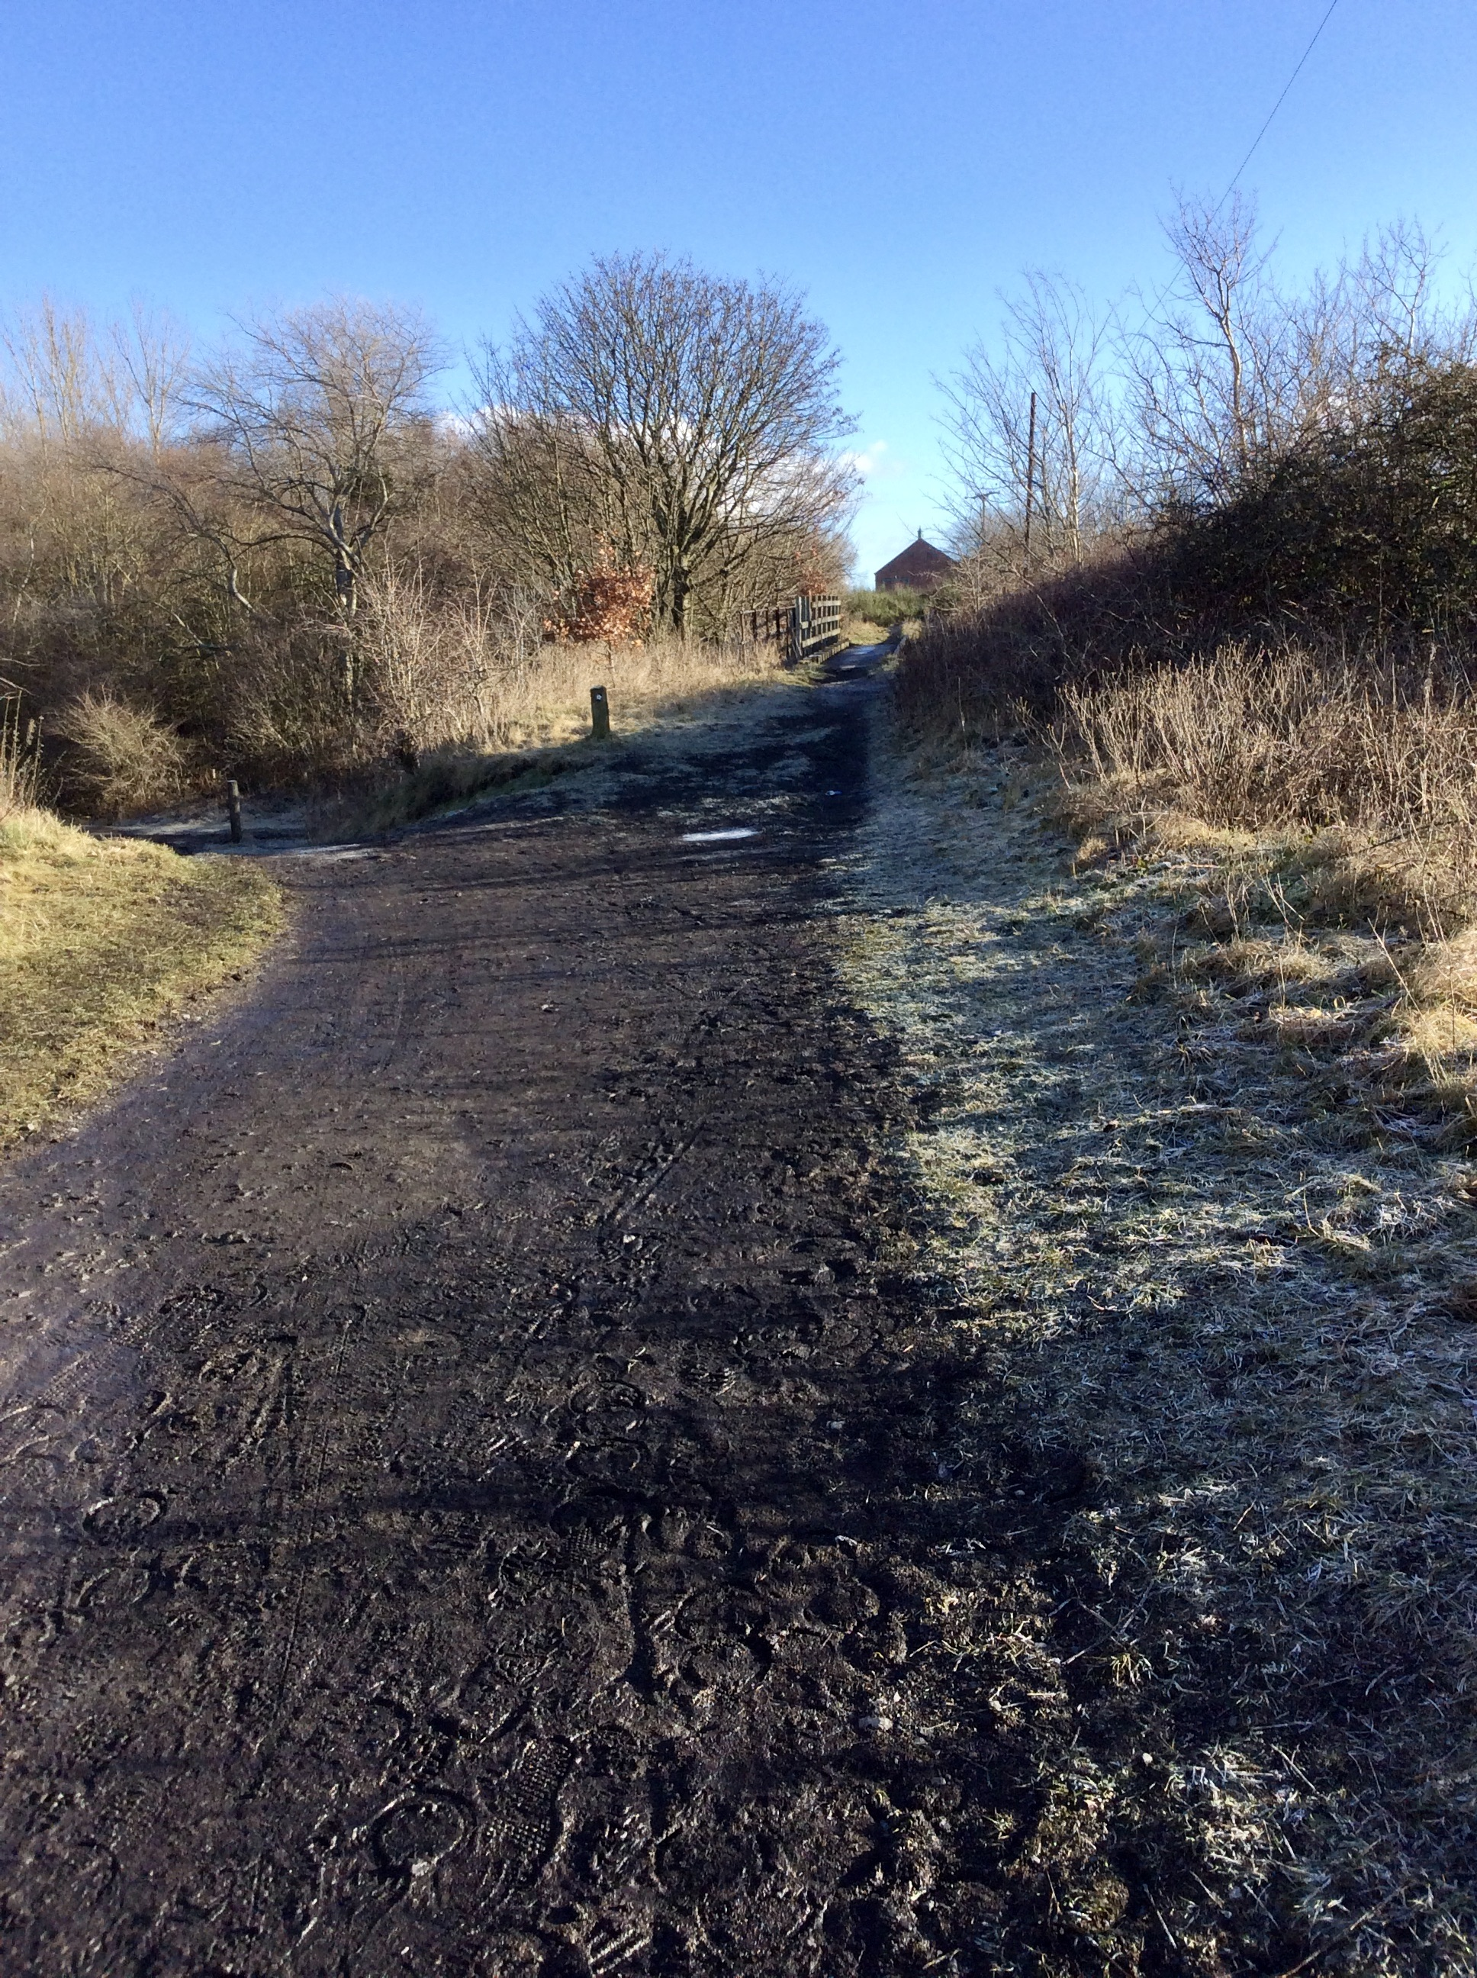
This is the start of a long uphill section. Too steep for locomotives to pull wagons, so they were moved by rope haulage. This section controlled from the Black Fell hauler at Eighton Banks. As you ascend keep looking back as view unfolds (good excuse to have breather!).
At the top of the bank, you will see a narrow metal bridge where rail tracks begin. This is where you leave the Bowes and return to the Pelaw Main track.
Across the bridge there is a building further down the Bowes track. This is the Black Fell Hauler house. Where the winding engine pulled full wagons up and lowered empty down the incline.

Turn left down the bank and look back towards the metal bridge. This is where, in 1855, the Bowes railway was built over the older Pelaw Main line (dating from the first decade of the 1800’s).

Continue north on the PM track. It makes a sharp left turn soon to skirt the field edge, but the railway went straight on towards the buildings on the hill.

The field you are going to go round was the site of Mount Moor Colliery, which was in part responsible for the construction of the Bowes Railway in 1826.
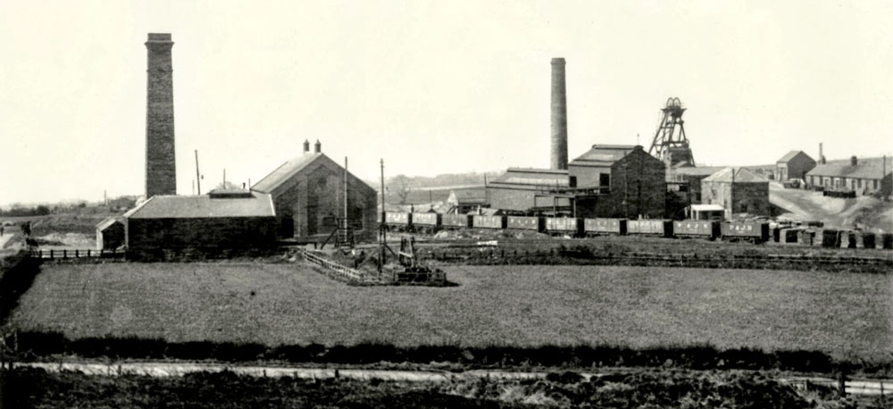
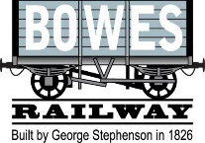
Skirt the edge of the field until you reach the road opposite the “Engine Room” pub. You are now back on the rail track. Walk up the path alongside the pub until the ground levels out. Another Hauler Engine house stood on the right of the track pulling the wagons up the incline you have just walked.

Note a stone structure on your left. This is a “Kip”, an artificial hill that the wagons travel over to enable the rope to be disconnected.

A sharp dip in the track as you pass the Mount Chapel is where there was a tunnel to allow the congregation to access the chapel without crossing the line.

At the Wagon Inn you cross the rail lines again. To your right the line is a 1950’s addition to allow the Pelaw main traffic to divert back to the Bowes line and down to the staiths at Jarrow rather than Pelaw.

Continue along the path until you cross the rails at a level crossing just before the line ends. Go immediately right up a short slope and follow the path between some houses. You then come out onto the road opposite the Wrekenton Health Centre. Cross the road and head diagonally right. Go along a track to the right of the houses facing you. This path then meets several other paths. Take the second left, heading north. When this path intersects another turn left alongside a steel fence. You are now back on the Pelaw Main line.

The path meets Old Durham Road where you cross and almost immediately turn left onto a footpath/cycleway. Continue downhill alongside Ravensworth Golf Course until the path brings you back to the Angel and your start point.

